EENG 3920: Modern Communication Systems Design

# **Lab 5: Phase-Shift Oscillator**

Group 5

Victor Rodriguez (victorcuba92@gmail.com)

Mohammad Qawash (MohammadQawash@my.unt.edu)

John Rolfe (JohnRolfe@my.unt.edu)

Natalie Powers (NataliePowers@my.unt.edu)

Nathan Ruprecht (nathan.ruprecht@outlook.com)

**Date of Submission: 10 March 2016**

**Section 1**

**Introduction and Learning Objective**

EENG 3920 is the project design course for electronics courses. Students are required to design electronic communication systems with electronic devices such as MOS transistors, capacitors and resistors. The design and simulation tool is NI ELVIS platform. Topics include LC circuits and oscillators, AM modulation, SSB communications, and FM modulation. At the end of the class, the student should be able to: Understand fundamental concepts and circuits used in communication systems; Describe principles and theory of various communication techniques such as AM, FM, and SSB; Conduct effective analysis and interpretation of the experiments; Demonstrate the ability to identify, analyze, and solve technical problems; Creatively apply the course topics to designs; Simulate and analyze advance electronics circuits with NI ELVIS instruments and other test equipment.

For this experiment we investigated the behavior of a negative clamper, studied class C bias and amplification, and understood the theory of frequency multiplication.

**Safety guidelines**

As mentioned in the lab procedures, safety is extremely important in the lab. In the event of electrical fire, the session 1 lecture note states to use the fire extinguisher, located at the front of the lab, then to vacate the lab, close the door and ring the fire alarm.

**Section 2 / 3**

**Theoretical Background**

In this lab we become familiar with Barkhausen criterion. We generally use this in operational amplifier circuits and negative feedback circuits to prevent them from oscillating. The Barkhausen criterion help us to determine when a linear electronic circuit will oscillate. In our lab, we were to predict if the amplifier will oscillate by testing the circuit in the open loop mode. When an amplifier is operating without feedback it is considered in the open loop mode. An oscillator consists of three essential parts: an amplifier, a wave shaping network, and a postive feedback path. The wave shaping network can consist of filters that are responsible of shaping the frequency produced, part of the feedback is fed back into an input of the amplifier to maintain a constant output signal.

**Exercises**

Procedure:

For this lab, we built the given circuit then tested it with a 100mV input at the test frequencies of 500Hz, 650Hz, 800Hz, 950Hz, 1100Hz, 1250Hz, 1400Hz, 1550Hz, 1700Hz, 1850Hz, and 2000Hz.

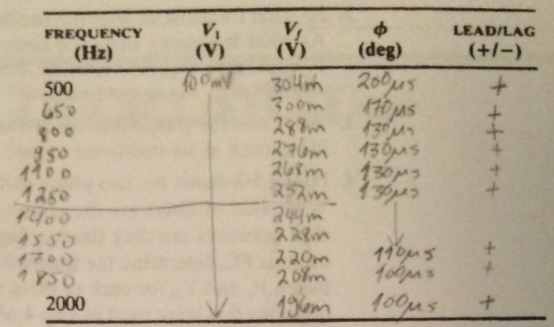

The point was to observe the output voltage to get a gain at each frequency and also see the phase shift. Then we just observed the output of the closed loop circuit at each testing point, recording the amplitude and phase shift at 2kHz.

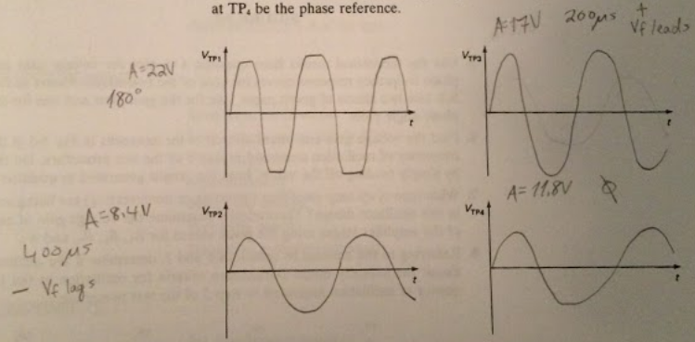

**Section 4**

**Conclusion**

In this lab, we spent our time understanding the observing phase shifting and gain to deal with the Barkhausen criterion. Seeing as the circuit passes the criteria so long as the gains, when all multiplied together, are greater than one, along with all the phase shifts add up to be 0 degrees. We tested 11 frequencies ranging from 500 to 2000 Hz (inclusive) and our results showed the the circuit did not pass this test.

Follow Up Questions:



|  |  |  |  |
| --- | --- | --- | --- |
| Test Frequency (Hz) | Voltage gain (Vf/V1) | Phase Data (seconds) | Phase Data (degrees) |
| 500 | 3.04 | 200us | 36 |
| 650 | 3.0 | 170us | 39.78 |
| 800 | 2.88 | 130us | 37.44 |
| 950 | 2.75 | 130us | 44.46 |
| 1100 | 2.68 | 130us | 51.48 |
| 1250 | 2.52 | 130us | 58.5 |
| 1400 | 2.44 | 130us | 65.52 |
| 1550 | 2.28 | 130us | 72.54 |
| 1700 | 2.2 | 110us | 67.32 |
| 1850 | 2.08 | 100us | 66.60 |
| 2000 | 1.95 | 100us | 72 |

2. All frequencies have a loop gain greater than 1, while no frequencies have a phase difference

of 0 degrees. This is different than our results in step 5 which has VTP4 having a phase

difference of 0 degrees.

3. R9 simulated a load resistor. It had the same value as R8 to not skew results.

4. The left portion of the circuit is a low pass filter, while the right side is a high pass filter. They are lead networks since our results are all lead values. We attempted to do hand analysis because SPICE decided to not work with us. We found an equation online that the lowpass filter would have a gain equal to the total impedance divided by 2 times pi times the test frequency. Below is an excel sheet that does the math for us.

|  |  |  |  |  |
| --- | --- | --- | --- | --- |
| LPF |  |  |  |  |
| Test frequency | Gain | Xc | Z | Phase |
| 500 | 0.00019 | 0.00032 | 1.65 | 0.00052 |
| 650 | 0.00015 | 0.00024 | 1.65 | 0.00067 |
| 800 | 0.00012 | 0.0002 | 1.65 | 0.00083 |
| 950 | 0.0001 | 0.00017 | 1.65 | 0.00098 |
| 1100 | 8.8E-05 | 0.00014 | 1.65 | 0.00114 |
| 1250 | 7.7E-05 | 0.00013 | 1.65 | 0.0013 |
| 1400 | 6.9E-05 | 0.00011 | 1.65 | 0.00145 |
| 1550 | 6.2E-05 | 0.0001 | 1.65 | 0.00161 |
| 1700 | 5.7E-05 | 9.4E-05 | 1.65 | 0.00176 |
| 1850 | 5.2E-05 | 8.6E-05 | 1.65 | 0.00192 |
| 2000 | 4.8E-05 | 8E-05 | 1.65 | 0.00207 |

|  |  |  |  |  |
| --- | --- | --- | --- | --- |
| HPF |  |  |  |  |
| Test frequency | Gain | Xc | Z | Phase |
| 500 | 31.6228 | 0.00032 | 52.1776 | -2.67005 |
| 650 | 31.6228 | 0.00024 | 52.1776 | 11.4872 |
| 800 | 31.6228 | 0.0002 | 52.1776 | 2.61636 |
| 950 | 31.6228 | 0.00017 | 52.1776 | 1.61125 |
| 1100 | 31.6228 | 0.00014 | 52.1776 | 1.20202 |
| 1250 | 31.6228 | 0.00013 | 52.1776 | 0.97289 |
| 1400 | 31.6228 | 0.00011 | 52.1776 | 0.82363 |
| 1550 | 31.6228 | 0.0001 | 52.1776 | 0.7174 |
| 1700 | 31.6228 | 9.4E-05 | 52.1776 | 0.6373 |
| 1850 | 31.6228 | 8.6E-05 | 52.1776 | 0.57441 |
| 2000 | 31.6228 | 8E-05 | 52.1776 | 0.52352 |

5.

LPF

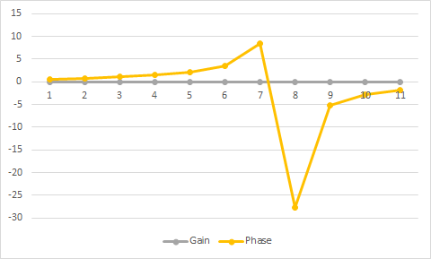

HPF

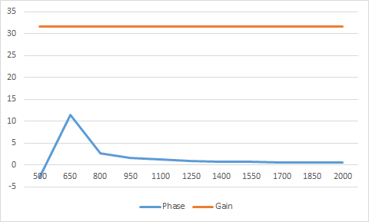

6.

|  |  |  |  |
| --- | --- | --- | --- |
| Testing Point | Test Frequency (Hz) | Gain (V/V) | Phase shift (deg) |
| 1 | 2000 | 440 | 180 |
| 2 | 2000 | 168 | 288 |
| 3 | 2000 | 340 | 144 |
| 4 | 2000 | 236 | 0 |

7. They’re both inverting op amps! Both of them have a gain of -2.1.

8. No. Although the gains would multiply to be greater than 1, the phase shifts do not add up to be 0.

# **References**

Agilent Technologies, 2007, *Agilent 34401A 6 ½ Digit Multimeter, User’s Guide*.